Posted 08/16/2012 at 11:04 am by JAV

Town Hall Building Committee

DRAFT Agenda
Fireplace Room, Old Library
Tuesday August 21, 2012
7:00 PM

- Approve minutes

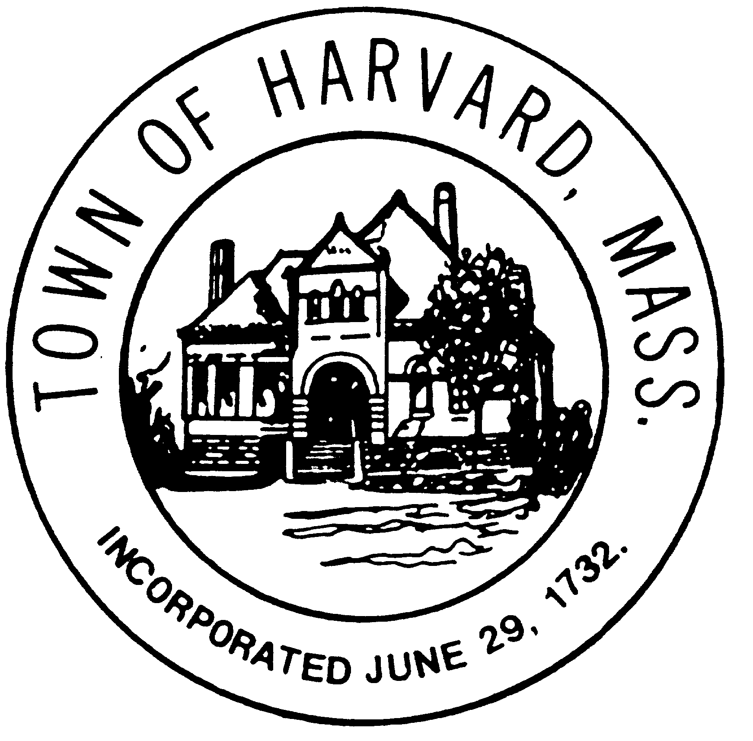
- Approve invoices

- Discuss LLB agreement if needed

- Update on Ayer Rd. setback issue

- Agenda and date for next meeting(s)

- New business

